**SYSTEM DESIGN**

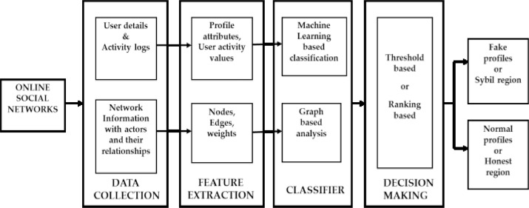

We presented a machine learning & natural language processing system to observe the false profiles in online social networks. Moreover, we are adding the SVM classifier and naïve bayes algorithm to increase the detection accuracy rate of the fake profiles.

The presented process used Facebook profile to notice false profiles. The working method of the proposed procedure includes three principal phases; 1. NLP Pre-processing 2. Principal Component Analysis(PCA) 3. Learning Algorithms

1. To minimize indexing (or knowledge) records dimension of the textual content records i. Stop words bills 20-30% of total phrase counts in a special textual content records ii. Stemming may just diminish indexing size as much as forty- 50%

2. To make stronger the efficiency and effectiveness of the IR method i. Stop words aren't valuable for shopping or textual content mining and so they may just confuse the retrieval system ii. Stemming used for matching the similar words in a text record